
Touchstones
Netcards

Communion Netcards with Text

Art HRJ
Beer HRJ
Brokenness HRJ
Caring HRJ



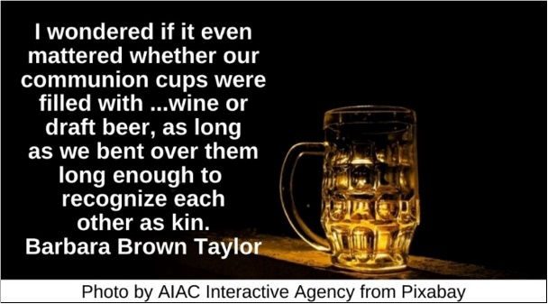

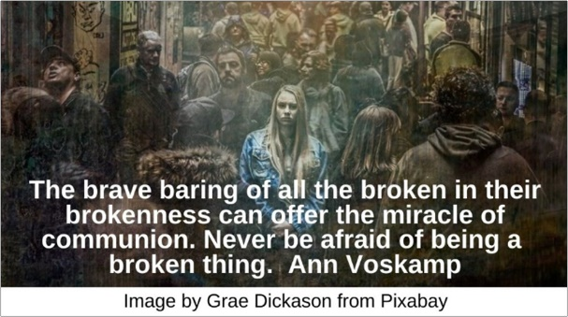

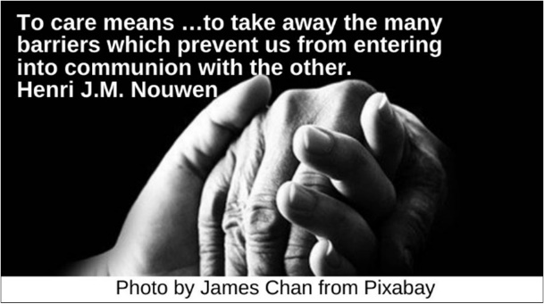
Charlotte’s Web HRJ
Cooking HRJ
Dance HRJ
Dandelion HRJ



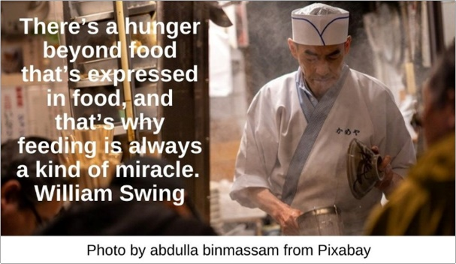

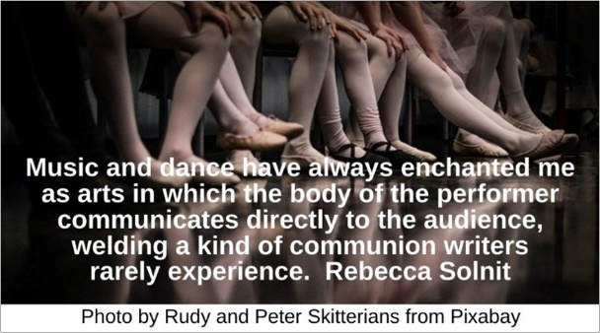

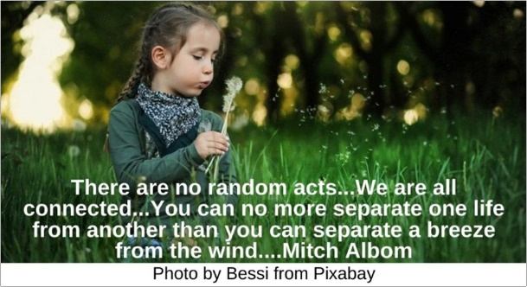
Day of the Dead HRJ
Dining HRJ
Earth HRJ
Embrace HRJ

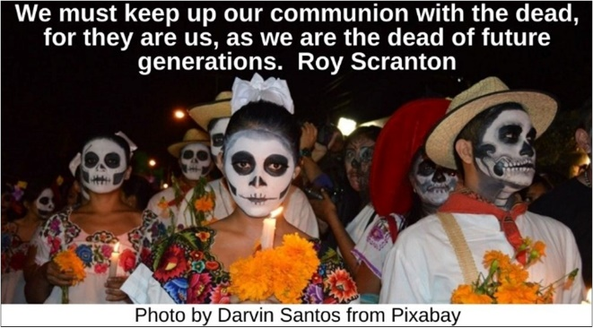







Fly Fishing HRJ
Friends HRJ
Healing HRJ
Hungry HRJ

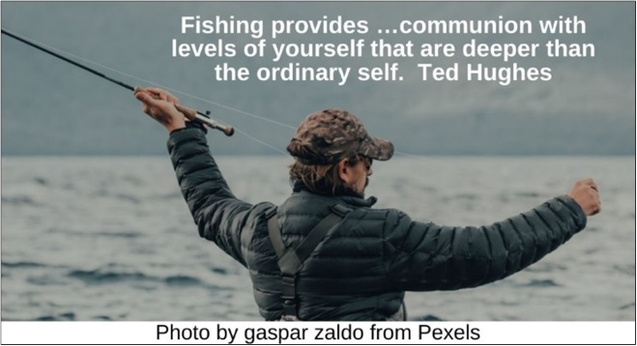

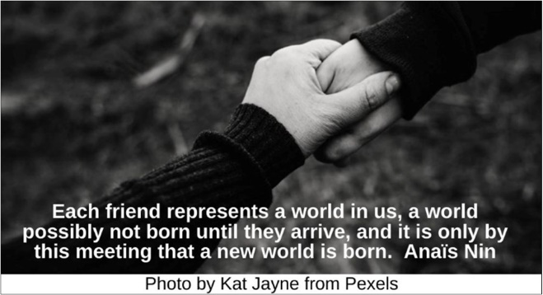

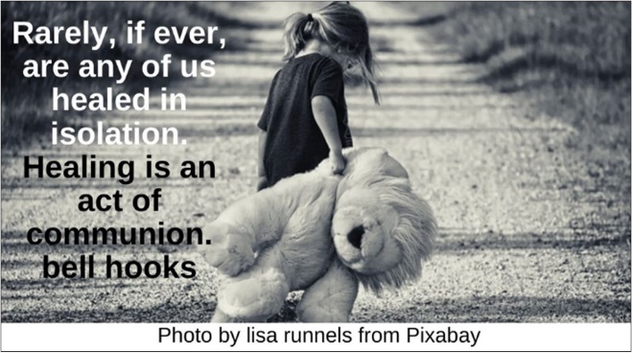

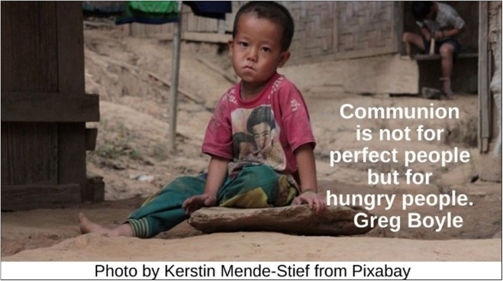

Hurt HRJ
Listening HRJ
Planet Earth HRJ
Reading a Book HRJ



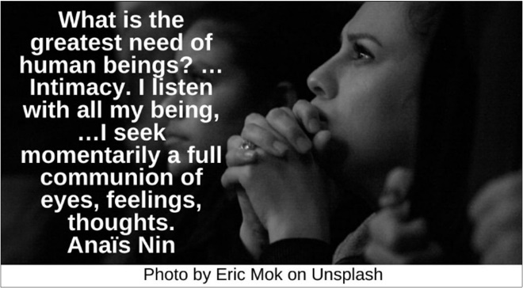





Saxophone Player HRJ
Silence HRJ
Solitude HRJ
Suffering HRJ

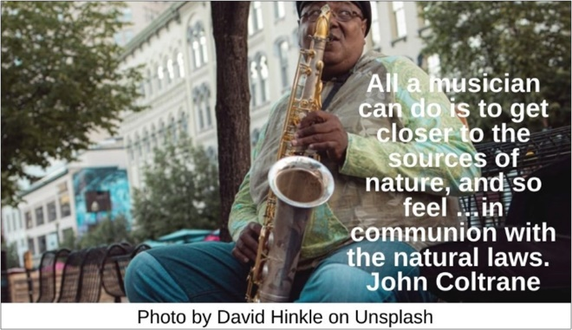







The Planets HRJ
Theater HRJ
Therapy HRJ
Universe HRJ



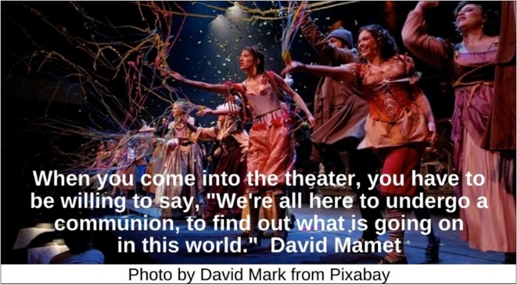

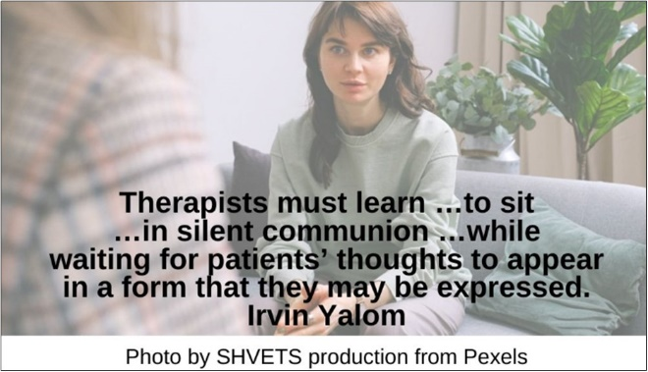



Walking HRJ
Weaving HRJ
Woods HRJ



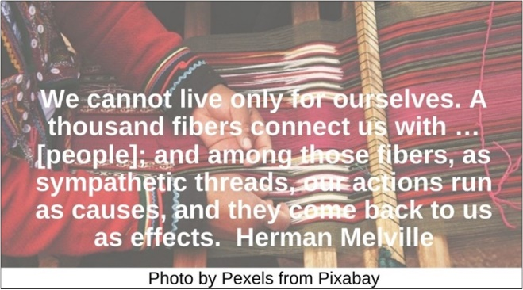



Text of Quotes
Art HRJ
Commit to finding the true nature of art. …Go for that …real communion with your soul, and …that communion with others. Anna Deavere Smith

Beer HRJ
Sometimes I wondered if it even mattered whether our communion cups were filled with consecrated wine or draft beer, as long as we bent over them long enough to recognize each other as kin. Barbara Brown Taylor

Brokenness HRJ
The brave baring of all the broken in their brokenness can offer the miracle of communion. Never be afraid of being a broken thing. Ann Voskamp

Caring HRJ
To care means …to take away the many barriers which prevent us from entering into communion with the other. Henri J.M. Nouwen

Charlotte’s Web HRJ
“Why did you do all this for me?” Wilbur asked. “I don't deserve it. I've never done anything for you.” “You have been my friend,” replied Charlotte. “That in itself is a tremendous thing.” E.B. White

Cooking HRJ
There’s a hunger beyond food that’s expressed in food, and that’s why feeding is always a kind of miracle. William Swing

Dance HRJ
Music and dance have always enchanted me as arts in which the body of the performer communicates directly to the audience, welding a kind of communion writers rarely experience. Rebecca Solnit

Dandelion HRJ
There are no random acts...We are all connected...You can no more separate one life from another than you can separate a breeze from the wind.... Mitch Albom

Day of The Dead HRJ
We must keep up our communion with the dead, for they are us, as we are the dead of future generations. Roy Scranton

Dining HRJ
Whenever people eat or drink together, it's communion. Thomas C. Foster

Earth HRJ
You may say I'm a dreamer, but I'm not the only one. I hope someday you'll join us. And the world will live as one. John Lennon

Embrace HRJ
To love is to be in communion with the other…. Paulo Coelho

Fly Fishing HRJ
Fishing provides …communion with levels of yourself that are deeper than the ordinary self. Ted Hughes

Friends HRJ
Each friend represents a world in us, a world possibly not born until they arrive, and it is only by this meeting that a new world is born. Anaïs Nin

Healing HRJ
Rarely, if ever, are any of us healed in isolation. Healing is an act of communion. bell hooks

Hungry HRJ
Communion is not for perfect people but for hungry people. Greg Boyle

Hurt HRJ
This is the foundation of Intimate Communion: to practice opening your heart in every moment, including when you feel hurt. David Deida

Listening HRJ
What is the greatest need of human beings? …Intimacy. I listen with all my being, …I seek momentarily a full communion of eyes, feelings, thoughts. Anaïs Nin

Planet Earth HRJ
We are all connected; To each other, biologically. To the earth, chemically. To the rest of the universe atomically. Neil DeGrasse Tyson

Reading a Book HRJ
…Nothing can replace the exact, complicated, subtle communion between absent author and entranced, present reader. Julian Barnes

Saxophone Player HRJ
All a musician can do is to get closer to the sources of nature, and so feel …in communion with the natural laws. John Coltrane

Silence HRJ
No person is your friend who demands your silence, or denies your right to grow. Alice Walker

Solitude HRJ
The measure of your solitude is the measure of your capacity for communion. Henri J.M. Nouwen

Suffering HRJ
Whatever we suffer, we suffer it in communion with all of humanity, and yes, all of creation. Henri J.M. Nouwen

The Planets HRJ
For mystics …the inward odyssey is also an upward odyssey, a quest for personal and vital communion with an infinite Being. David C. Downing

Theater HRJ
When you come into the theater, you have to be willing to say, "We're all here to undergo a communion, to find out what is going on in this world." David Mamet

Therapy HRJ
Therapists must learn …to sit …in silent communion …while waiting for patients’ thoughts to appear in a form that they may be expressed. Irvin Yalom

Universe HRJ
We are one huge universe speaking and listening to itself. Francis Lucille

Walking HRJ
The people setting out on these walks …were looking for a mystical communion with the land; they walked backwards in time to an imagined past suffused with magical, native glamour Helen Macdonald

Weaving HRJ
We cannot live only for ourselves. A thousand fibers connect us with …[people]; and among those fibers, as sympathetic threads, our actions run as causes, and they come back to us as effects. Herman Melville

Woods HRJ
Every walk to the woods is a religious rite …. Communion …is at all hours, and the bread and wine are from the heart and marrow of Mother Earth. John Burroughs

